Morning Prayer Lord's Prayer Rev. Scott Wilks

Presentation of His Tithes and Our Offerings

†Doxology Praise God, from Whom All Blessings Flow UMH 94
LASST UNS ERFREUEN
Offering Prayer
Scripture Lesson Matthew 6: 9-13 Rev. Scott Wilks

Morning Message Prayer does not change God,
Prayer changes us: a basic model Rev. Scott Wilks

Communion

Communion Anthem How Beautiful Twila Paris
arr. Harlan

GOING FORTH TO SERVE

†Hymn Lord I Want to Be a Christian UMH402
NETTLETON
Choral Benediction Lord I Want to Be a Christian

The altar flowers are given to the Glory of God and in Honor of Lucas Scott,
Grand Son-in-Law, Stationed in South Korea by Joe &Pam Rainey

Postlude

(†) Please stand as you are able

First Sunday in Lent

March 1, 2020 10:00AM

Prelude

Lighting of the Altar Candles Acolyte, Luke Hatmaker

SONGS OF INVITATION

†Hymn Since Jesus Came into My Heart (V1-2) Insert

†Hymn Take Time to Be Holy (V1 & 4) UMH395
HOLINESS
†Hymn Seek Ye First UMH395
SEEK YE

Words of Welcome and Announcements
Please sign the friendship register and pass it to your neighbor.
The Ushers will receive them during the first hymn.

†Call to Worship Boyce Evans, Worship Leader

Oh God, have mercy on us, we pray.
In your mercy, make us clean from our sins.
Wipe away every failing and make us new in your sight.
Restore us, deliver us, and re-create us, O Lord.

†Hymn I Need Thee Every Hour UMH397
NEED

RESPONSE

Affirmation of Faith The Apostles Creed UMH881

†Gloria Patri Glory be to the Father UMH 071
GREATOREX
Psalter Psalm 51: 10-17 Boyce Evans

HAPPY BIRTHDAY – March 1^{st _} March 8 th
03/05 Ben Sellers
The gift of life is precious. This church family thanks God for you.

SCHEDULE FOR MARCH 1ST– MARCH 8TH
Sunday 03/01 9:00a Sunday School
10:00a Morning Worship Service
Monday 03/02 6:00p-8:00p Boy & Cub Scouts Meetings
6:30p Church Council Meeting
Tuesday 03/03 4:30p Delta Kappa Gamma Meeting
6:00p-8:00p Girl Scout Meeting
Wednesday 03/04 12:00p-3:00p Wednesday Club Meeting
5:30P-6:00P Fellowship Dinner
6:00p-7:15P Adult Bible Study
6:00p-7:15p Youth & Children Program
7:15p Choir practice
Thursday 03/05 10:00 Morning Prayer in the Chapel
11:30 Grace Circle Meeting
5:30p-6:30p Food Pantry
Sunday 03/08 9:00a Sunday School
10:00a Morning Worship Service
Girl Scout Sunday

Pastor Scott may be reached at parsonwilks@gmail.com
Or (540) 818-9155 (text or voice)
The Church Office is closed on Fridays
to allow the pastor and staff a Sabbath day

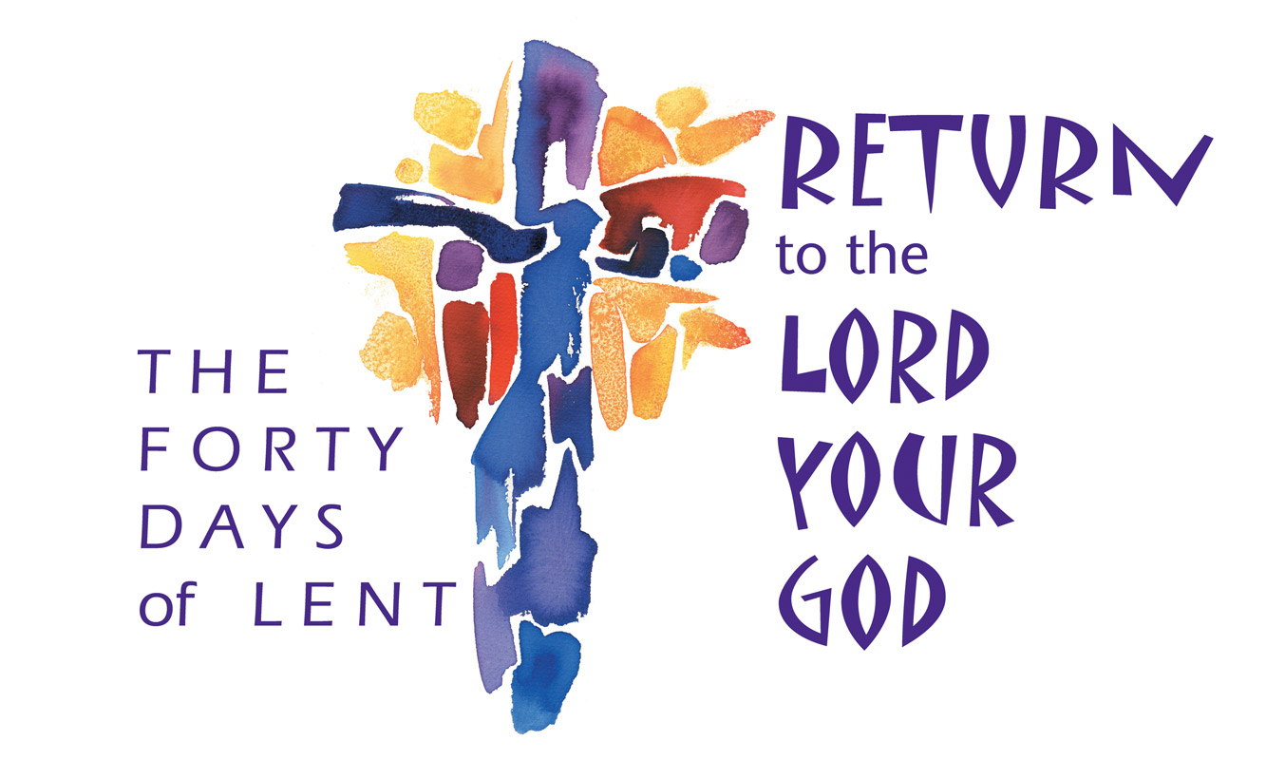

The Mission of Memorial United Methodist Church is to make
disciples of Jesus Christ and to serve others

Our Gifts

Last week: Year to date Goal to date_
$2,670.00 $32,875.00 $40,992.00

Attendance:
Last Week – 80 Last Year - 66

Memorial United Methodist Church
323 North Main Street
Clinton, TN 37716
(865) 457-2287
mumcclinton.org

Rev. Scott Wilks Joshua Allen
Pastor Music Director

