†Gloria Patri Gloria, Gloria UMH 072
Gloria Canon
Psalter Psalm 32 Nancy Large

† Hymn Take My Life, and Let It Be UMH399
MESSIAH

Morning Prayer Lord's Prayer Rev. Scott Wilks

Presentation of His Tithes and Our Offerings

Offertory Anthem Make Me an Instrument Roger Emerson

Offering Prayer

Doxology Praise God, from Whom All Blessings Flow UMH 94
LASST UNS ERFREUEN

Scripture Lesson 1 Timothy 2:1-6 Rev. Scott Wilks

Morning Message Prayer does not change God, Rev. Scott Wilks
Prayer changes us: What to pray

GOING FORTH TO SERVE

†Hymn We Believe In One True God UMH85
RATISBON

Congregational Benediction To God be the Glory (V1) UMH98
TO GOD BE THE GLORY

The altar flowers are given to the Glory of God and in
GRATITUDE of Spring, Glorious Spring, by Bill and Alice Connell

(†) Please stand as you are able

Second Sunday of Lent

March 8, 2020 10:00 am

GATHERING AND PRAISE
Chiming of the Hour

Gathering You Are My Hiding Place arr. Tom Fetke

Words of Welcome and Announcements
Please sign the friendship register and pass it to your neighbor.
The Ushers will receive them during the first hymn.

Prelude
†Call to Worship Nancy Large, Worship Leader

Lord, Teach us to pray
for the coming of your Kingdom is at hand
Teach us to pray
for the daily necessities of life
Teach us to pray
for forgiveness and protection
Teach us to pray
to be closer to you

†Hymn To God Be the Glory UMH98
TO GOD BE THE GLORY

RESPONSE

Affirmation of Faith The Apostles Creed UMH881

HAPPY BIRTHDAY – March 8^{th _} March 15 th

The gift of life is precious. This church family thanks God for you.

SCHEDULE FOR March 8rd– MARCH 15th
Sunday 03/08 9:00a Sunday School
10:00a Morning Worship Service
Monday 03/09 6:00p-8:00p Boy & Cub Scouts Meetings
Wednesday 03/11 10:00a Prayer Study Class- Chapel
5:30P-6:00p Fellowship Supper for all
6:00p-7:15p Youth & Children Program
6:00p-7:15p Bible Study
7:15p Choir Practice
Thursday 03/12 10:00a Morning prayer – Chapel
Sunday 03/15 9:00a Sunday School
10:00a Morning Worship Service

Pastor Scott may be reached at parsonwilks@gmail.com
Or (540) 818-9155 (text or voice)
The Church Office is closed on Fridays
to allow the pastor and staff a Sabbath day

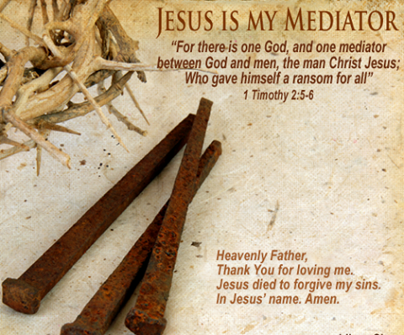

The Mission of Memorial United Methodist Church is to make
disciples of Jesus Christ and to serve others
Our Gifts

Last week: Year to date Goal to date_
$8,780.00 $38,985.00 $51,240.00

Attendance:
Last Week – 86 Last Year - 61

Memorial United Methodist Church
323 North Main Street
Clinton, TN 37716
(865) 457-2287
mumcclinton.org

Rev. Scott Wilks Joshua Allen
Pastor Music Director

